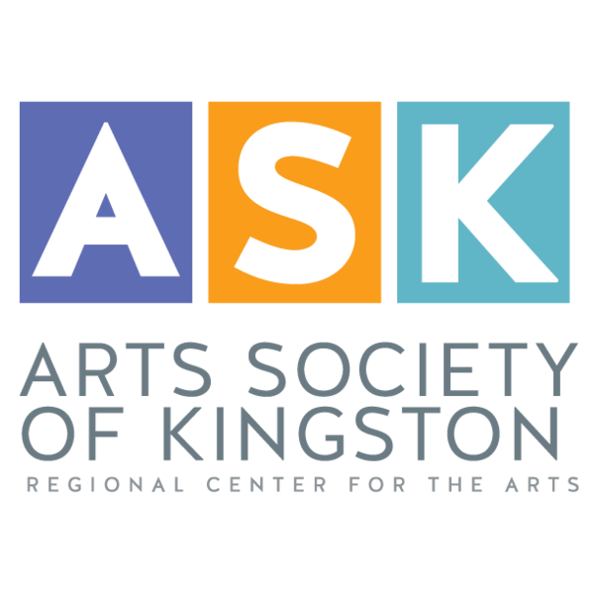

**For immediate release**

Contact name  
Telephone Number  
Email address

**Headline  
Sub-headline**

Kingston, NY - Date

First or lead paragraph that summarizes the rest of the press release. You want to concisely give the reader the benefits of attending your event.

Give a more detailed description of your event. You want to give enough information that your target audience is excited about attending your event. Keep it as short as possible. Be engaging and try to generate buzz with the details you give.

Enter the date, time and particulars of the event here.

For more information, contact (Name, phone and email), or visit the ASK website at https://askforarts.org

Closing boilerplate language:

The Arts Society of Kingston (ASK), utilizing its organization, expertise, and facilities, acts as an umbrella to foster and promote the arts in Kingston and the Mid-Hudson Valley.

Founded in 1995 by local artists in Kingston, NY, ASK today has grown to become a not-for-profit, 501c3, membership organization with over 300 members. Among ASK members you will find many talented, highly respected professional artists, as well as emerging artists and supporters of the arts.